Merry Christmas Rimrock students and parents!
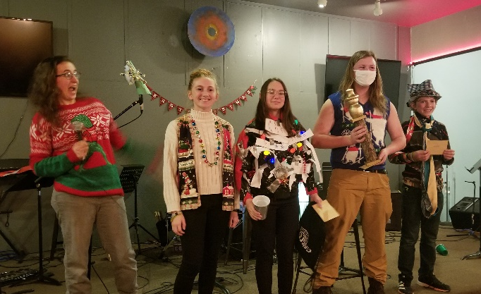
With Thanksgiving a few weeks in the rearview mirror and Christmas a few weeks ahead, here’s a glimpse at some of the holiday events on the horizon and beyond.

White Elephant Christmas Party
Last night was the Wednesday Night youth Christmas Party! Lots of hilarious gifts were given during the White Elephant Gift Exchange. There were a lot of very ugly Christmas sweaters & ties worn, but these four students (picture on the right) took the top spots! Thanks to everyone who brought a Christmas treat to share as well – it made for quite the special evening!

Christmas Break
We’ll be taking the Wednesdays of December 22 & 29 off and will resume Wednesday Nights for all ages again on January 5. We’ll also be having Family Worship on December 26 and January 2, which means we won’t have classes for middle school or high school those Sundays. We’ll resume Sunday morning classes on January 9. We’ll still have a couple of activities over break, so check out the events below!

Movie Night
Several students have organized a group to watch the upcoming Spiderman: No Way Home movie in theaters together. They wanted to invite the whole group to join them on Wednesday, December 22 for the 2:15pm showing at The Golden Ticket movie theater. To ensure everyone gets a seat, we encourage you to purchase tickets online in advance. Coordinate with your friends if you’d like to sit together. You can buy tickets for this showing here.
On our way home we’ll stop to grab a bite to eat at Culvers (near Sam’s Club) to discuss the movie and hangout until 6pm. Parents, if you’d like to know more about the content of the movie I’d encourage you to check out the review at Pluggedin.com. You’re also welcome to join us if you’d like to watch it too!

Ice Skating at the Plaza
It’s the most wonderful time of the year, and to kick off the New Year we thought it would be fun to meet at the Main Street Square skating rink! We hope you’ll lace up those skates and join us from 6-7pm on Saturday, January 1st.

Winter Whitewash
This is a retreat that includes a day of skiing in Laramie, WY for both Middle School and High School students taking place on January 28-30. Students can register at the door, but it would be helpful if students to turn in their forms and $60 deposit before January 5th and the remaining balance will be due January 19 if they’ve already registered. Registration forms are available at church (and also available on the youth webpage soon). More information about the retreat can be found on their event website.

Wednesday Nights
When we start back up again in January, we’ll be spending two more weeks finishing the book of Philippians, and then we’ll be jumping into the book of James. Hope to see you there!

Sunday Mornings
During the first service from 9-10am we have classes for our high school and middle school students. Frontline, the high school group, meets in the A-Frame. Four:Twelve (1 Tim 4:12) is the middle school group and meets in the Youth Center, which is the separate building on the west side of the church.
